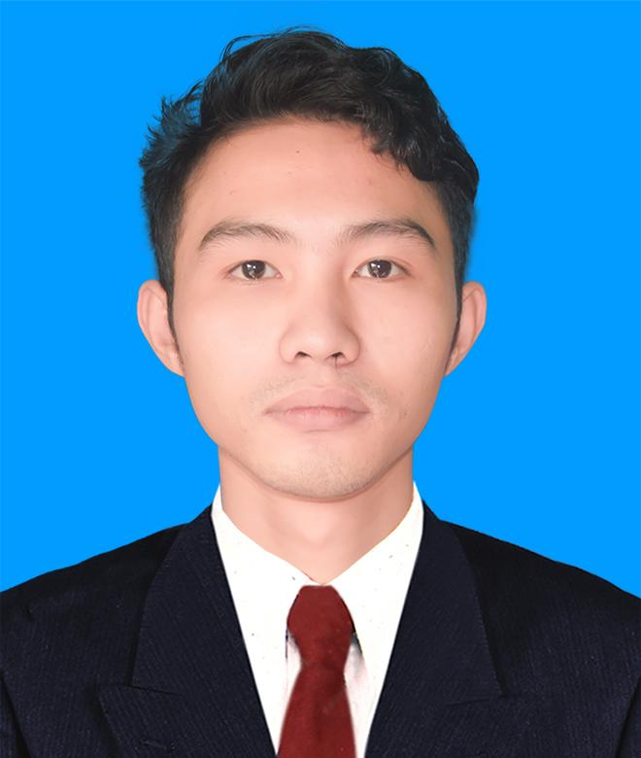
Mr. Myo Thant Kyaw

Software Engineer (Golang / Fintech Systems)
Address: 95 Aroozoo Ave, Singapore 539851
Email: myothantkyaw.dev@gmail.com | Phone: +6593586148
LinkedIn: linkedin.com/in/myo-thant-kyaw | GitHub: github.com/myothantdev

Professional Summary
Software Engineer with 6+ years of experience building scalable APIs and enterprise platforms across fintech, HR, and e-commerce domains.
Specialized in Golang and secure payment integrations, with strong expertise in high-throughput system design, event-driven architecture, and backend performance optimization.
Proven track record in optimizing API latency, database performance (PostgreSQL), and building reliable, scalable systems. Experienced in leading development teams and delivering full lifecycle systems from design to deployment.

Technical Skills
Languages: Go (Primary), TypeScript, PHP, JavaScript
Backend & Frameworks: Gin, Echo, Laravel
Databases & Caching: PostgreSQL, MySQL, Redis
APIs & Communication: REST, gRPC, Webhooks, OAuth2, XML
Architecture: Clean Architecture, Microservices
Messaging: RabbitMQ
Infrastructure: Linux, Docker, Nginx, GitHub Actions (CI/CD)
Cloud Platforms: AWS EC2, DigitalOcean, Alibaba Cloud
Security: PGP/JWE Encryption, Signature Verification
Tools: Git, Swagger/OpenAPI
Testing & Quality: Unit Testing (Go), SonarQube (SAST)
Frontend: HTML, CSS, TypeScript, JavaScript ( React, Next.js )

Professional Experience
Mobile Community Tech Pte Ltd
Senior Software Engineer | Singapore | Feb 2023 – Present
Responsibilities:
- Designed system architecture and database structures for fintech platforms, with unit testing.
- Integrated multiple financial services and payment APIs into unified systems.
- Modernized legacy services and migrated components to Golang-based architecture.
- Led a remote team of 5 developers to deliver projects on schedule.
- Managed full project lifecycle: development, testing, deployment, and maintenance.
- Built internal tools for KYC processing, settlement monitoring, and operational automation.
Key Projects:
- Payment Gateway System - Multi-channel payments with PayNow, Visa, and wallet integrations
- Virtual Bank System - Transaction management, and API integration with partner banks
- Remittance System - Cross-border payment processing platform integrating multiple providers
- Customer Onboarding System - (csonboard.mctpay.sg)
- AML Monitoring System
Achievements:
- Reduced manual reconciliation work by 60% by building automation tools.
- Improved transaction processing performance by 40% using Go channels, Redis, Async and DB indexing.
- Delivered multiple payment channels for a unified payment platform and integrated with major banks.

Myanmar Software Integrated Solutions Co. Ltd
Senior Web Developer | Myanmar | Sep 2020 – Jan 2023
Responsibilities:
- Led a team of three developers to deliver enterprise web applications.
- Gather business requirements and translate them into a digital system.
- Participated in a full development lifecycle including design, development, testing, and deployment.
- Implemented security best practices and code quality improvements using SAST tools.
- Managed Linux server configuration and application deployment.
Key Projects:
- Recruitment system - (jobspace.com.mm)
- HR management system (HRMS)
- Case management system (Government law cases)
- Student Information System
- E-commerce Platform - (sbgg.com.mm)
Achievements:
- Developed and improved Moodle LMS plugins to extend platform functionality.
- Led a small development team and managed multiple project deliveries.
- Recognized with increased responsibilities and salary progression.

AcePlus Solutions Co. Ltd
Web Developer | Myanmar | Feb 2018 – Aug 2020
Responsibilities:
- Developed web applications based on business and system requirements.
- Collaborated with project managers and developers to deliver projects successfully.
- Participated in the full development lifecycle including testing and deployment.
- Built applications from scratch based on database and system architecture.
Key Projects:
- Restaurant Ordering System
- Member Management System
- Insurance Management System
- Clinic Management System
- Assignment Management System (English Tuition)
Achievements:
- Delivered multiple projects concurrently in a fast-paced development environment.
- Managed Linux cloud servers for deployment and system operations.
- Contributed to system architecture improvements, leading to promotion to Mid-Level Developer.

Education
Bachelor of Science (Physics)
West Yangon University, Myanmar
Jun 2014 – Sep 2017

Certifications
- Web Fundamentals Certification - RIG
- Web Application Development with PHP - RIG
- Web Application Penetration Testing - IAT
- VCTA Data Center Virtualization 2021 - IAT
- Linux Essential - LPI (lpi.org/v/LPI000511691/yeq3h9h3yd)

